Contents

Model 1 - Conv3D 2

1. Batch size : 30 , learning rate = 0.0001 , image size 120x120 with 16 images per video 3

2. Batch size 30 , all 30 images per video, learning rate = 0.0001 with image size 120x120 4

3. batch size 40 , learning rate = 0.001 ,image size 120x120 with all 30 images in video 5

4. Batch size = 32 , learning rate = 0.001, image size 120x120 with all 30 images per videos 6

5. Batch size 32 , all 30 images per video, learning rate = 0.0001 , image size = 120x120 and epoch = 10 7

6. Batch size 32 , all 30 images per video, learning rate = 0.0001 , image size = 100x100 and epoch = 20 9

2. MODEL 2 - 2 Layer CON3D , 10

1. Batch size 32 , 30 images per video, learning rate = 0.0001 , image size = 100x100 and epoch = 20, with 64 filters in both the conv layer 10

2. Batch size 32 , 15 images per video, learning rate = 0.0001 , image size = 100x100 and epoch = 20, with 64 filters in both the conv layer 10

3. Batch size 32 , 22 images per video, learning rate = 0.0001 , image size = 100x100 and epoch = 20, with 64 filters in both the conv layer 11

4. Batch size 32 , 22 images per video, learning rate = 0.0001 , image size = 100x100 and epoch = 20, with 32 filters in both conv layer 11

5. Batch size 32 ,30 images per video, with initial learning rate = 0.0001 , image size = 100x100 and epoch = 20, with 32 filters in both conv layer 12

3. Model 3 - CNN+GRU 14

1. Batch size = 32 , learning rate = 0.001, epoch=20, included all the 30 images , image size = 100x100 , with relu activation in dense layer 14

2. Batch size = 32 , learning rate = 0.001, epoch=20, included all the 30 images , image size = 120x120 without relu activation in dense layer 15

3. Batch size 32, with initial learning rate = 0.0001, 15 images per video, image size = 120x120 , without relu activation in dense layer 16

4. Batch size 32, initial learning rate = 0.0001, 15 images per video, image size is 160x120 without relu activation in dense layer 17

5. Batch size 32, learning rate = 0.0001, 30 images per video, image size is 100x100, Number of units in GRU =128 , without relu activation in dense layer 18

6. Batch size 32, learning rate = 0.0001, 30 images per video, image size is 100x100, Number of units in GRU =128, by adding dropout 0.5 and without relu activation in dense layer 19

7. Batch size 32, learning rate = 0.0001, 30 images per video, image size is 100x100, Number of units in GRU =128, with batch normalisation in the conv 2D without relu activation in dense layer 20

8. Batch size 32, learning rate = 0.0001, 30 images per video, image size is 100x100, Number of units in GRU =128, with batch normalisation and dropout(.5) in the conv 2D, without relu activation in dense layer 21

4. Model 4 - CNN+LSTM 22

1. Batch size 32, learning rate = 0.0001, 30 images per video, image size is 100x100, with batch normalisation and dropout(.5) in the conv 2D, and passing through LSTM, without relu activation in dense layer 22

# 

# Model 1 - Conv3D

## Batch size : 30 , learning rate = 0.0001 , image size 120x120 with 16 images per video

## 

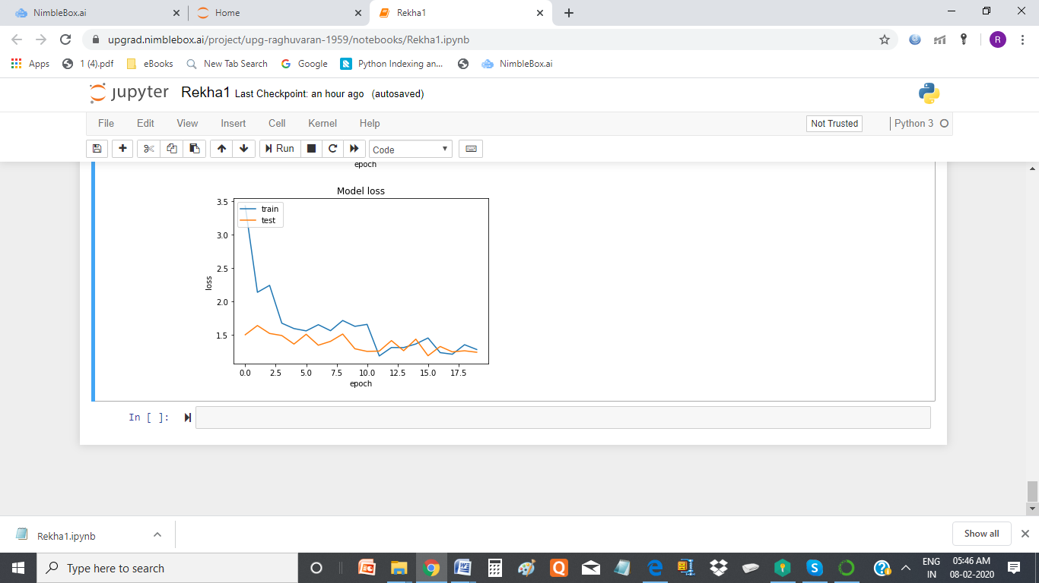

**Conclusion :** from the accuracy graph , model overfit lot in lot of epoc , so thought of increasing the number of images per video

## Batch size 30 , all 30 images per video, learning rate = 0.0001 with image size 120x120

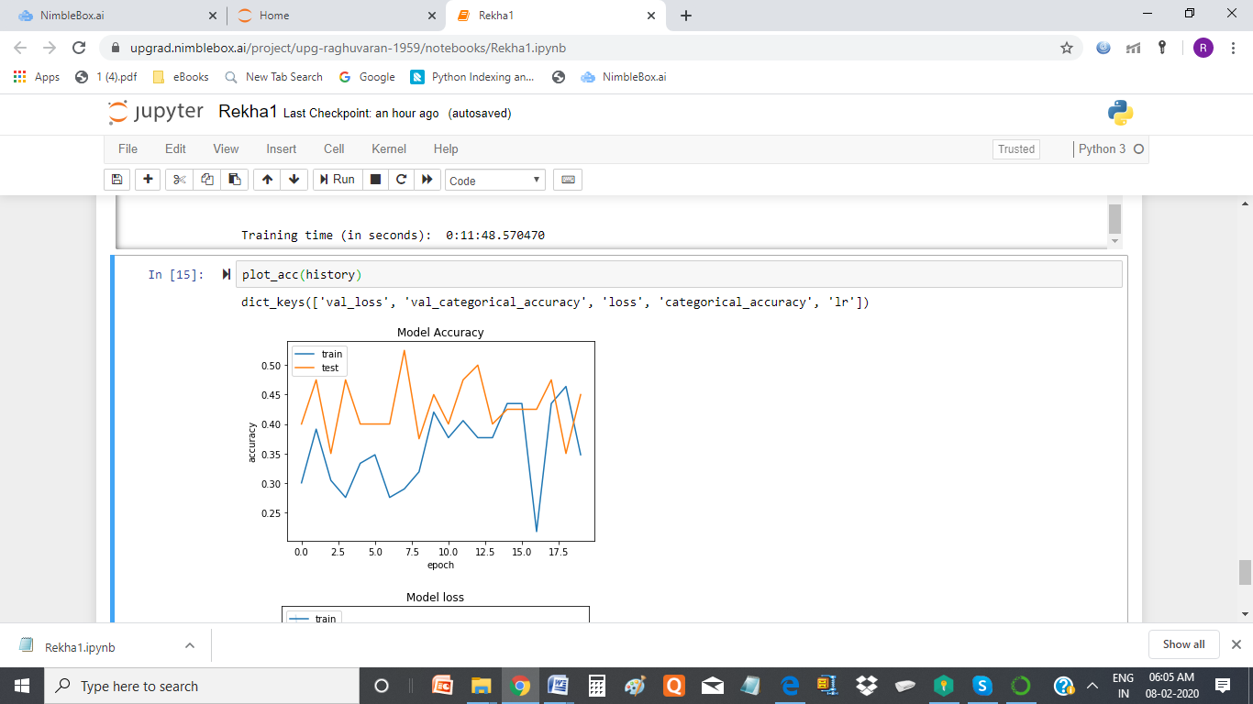

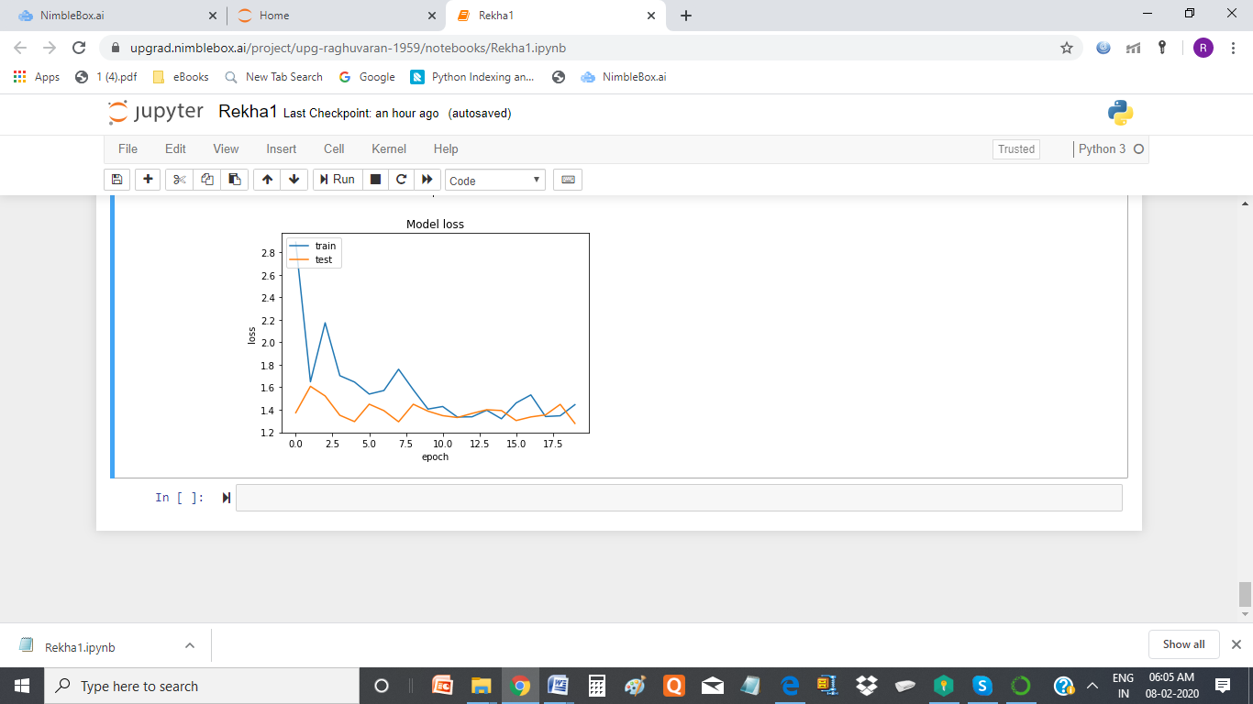

**Conclusion :** from the accuracy graph, this model looks better, as it is not over fitted, in most of the epoc, but the max accuracy is below 60%, so play with batchsize and learning rate

## batch size 40 , learning rate = 0.001 ,image size 120x120 with all 30 images in video

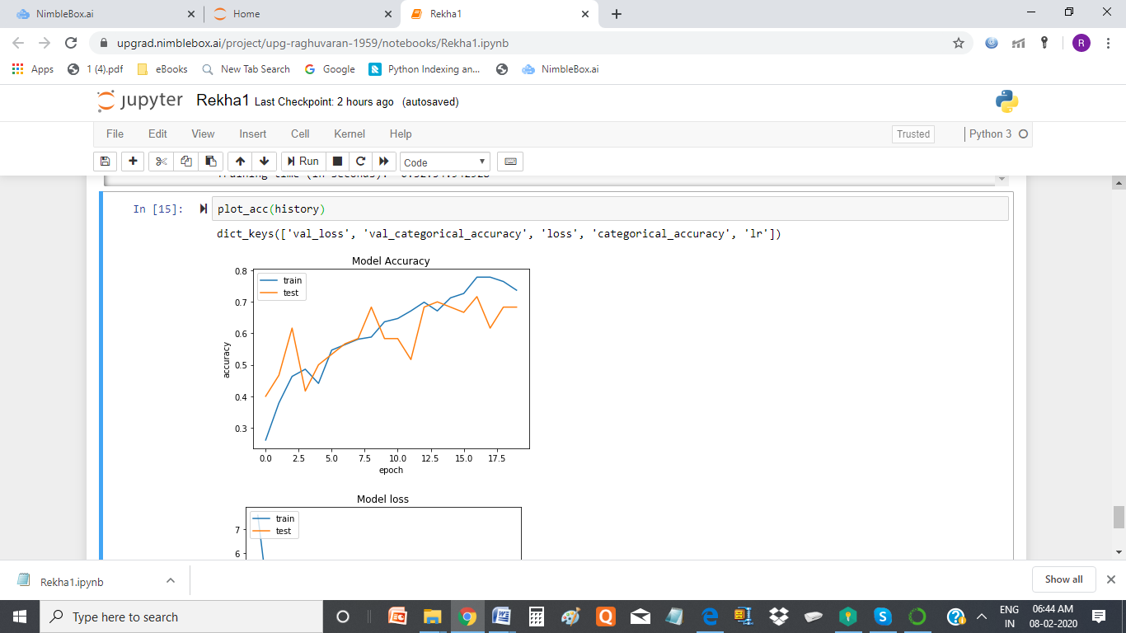

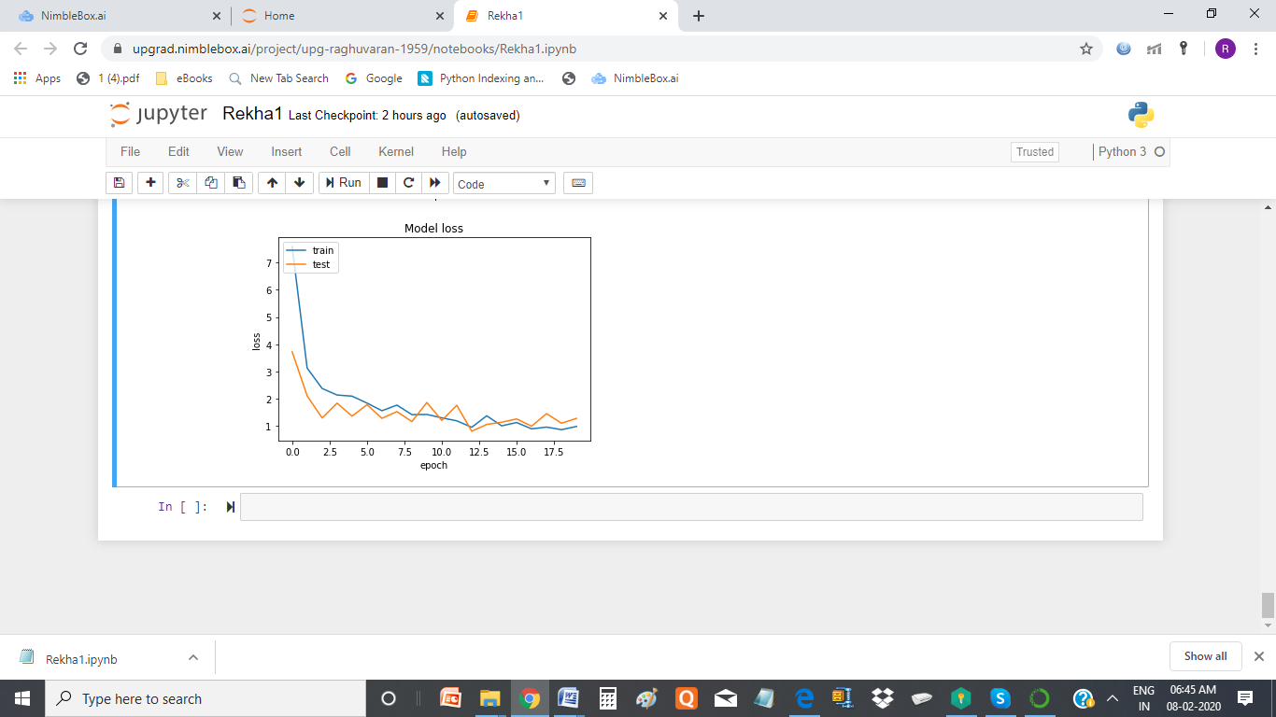

**Conclusion :** from the accuracy graph, this model is not good , it overfits in lot of epoc.

## Batch size = 32 , learning rate = 0.001, image size 120x120 with all 30 images per videos

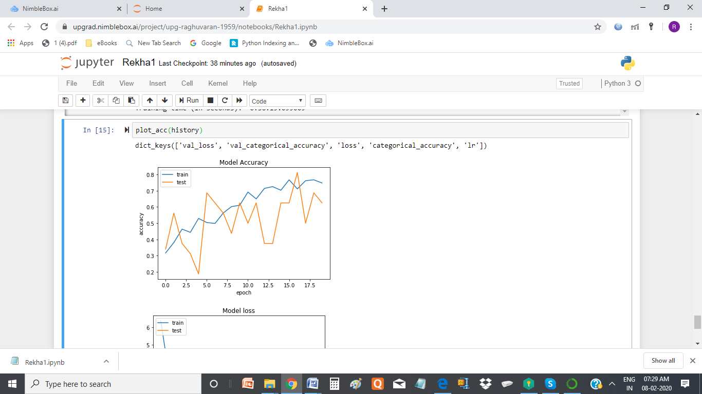

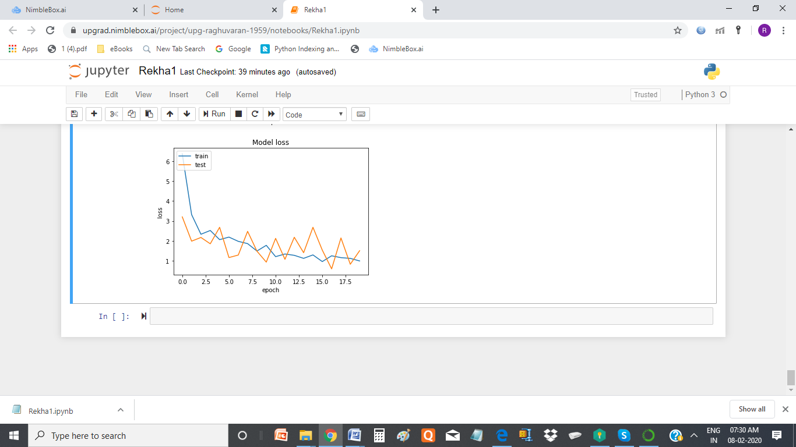

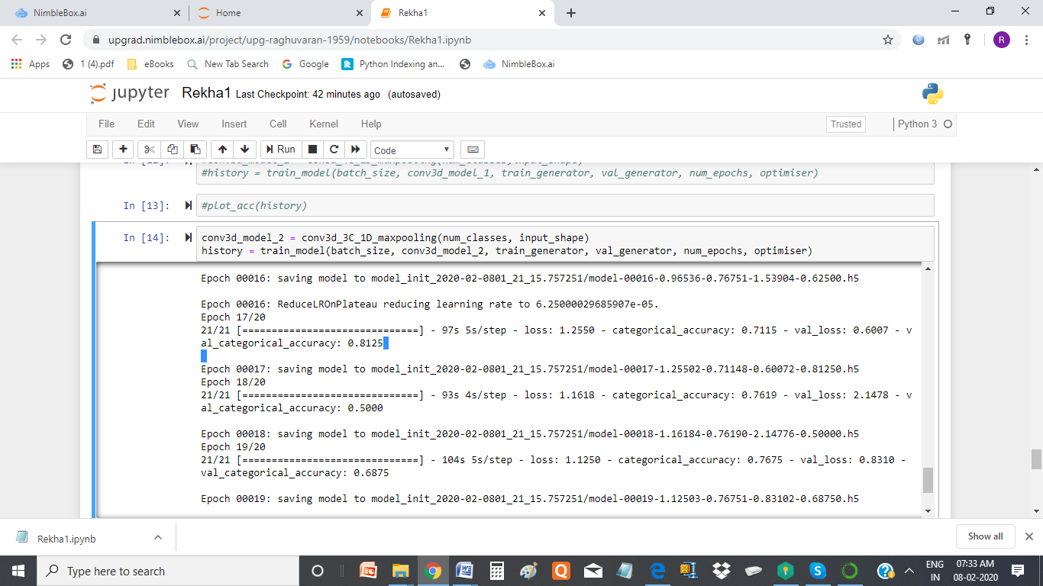

**Conclusion :** from the accuracy graph, this overfits in lot of epoc. Play with learning rate.

at one of the epoc validation accuracy is 81 %

## Batch size 32 , all 30 images per video, learning rate = 0.0001 , image size = 120x120 and epoch = 10

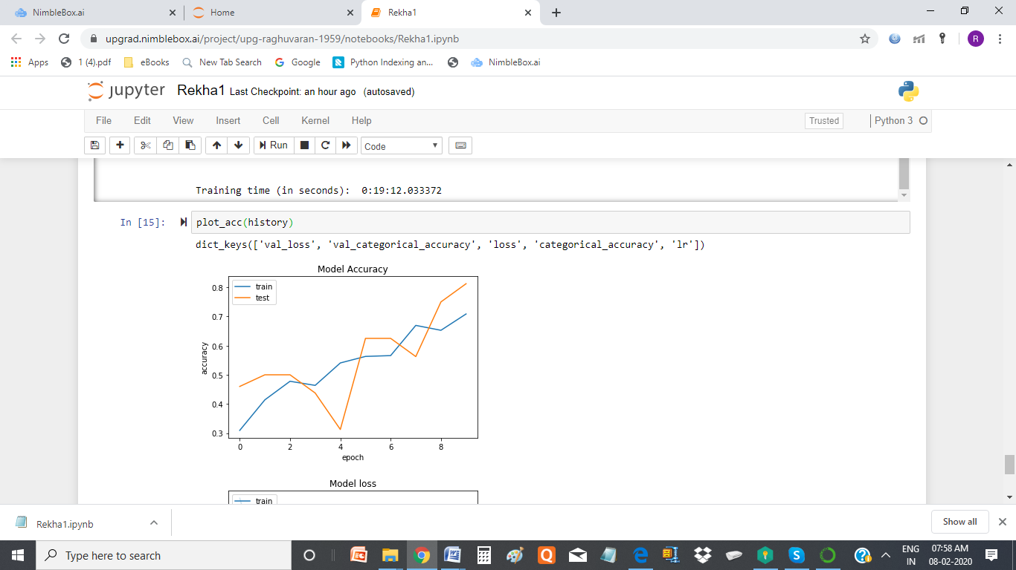

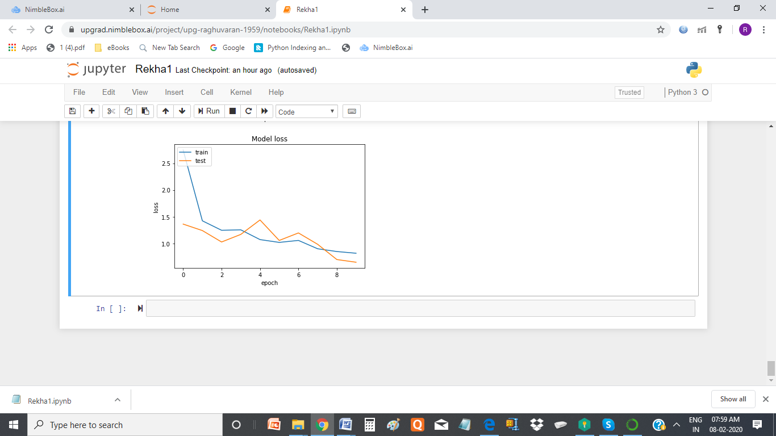

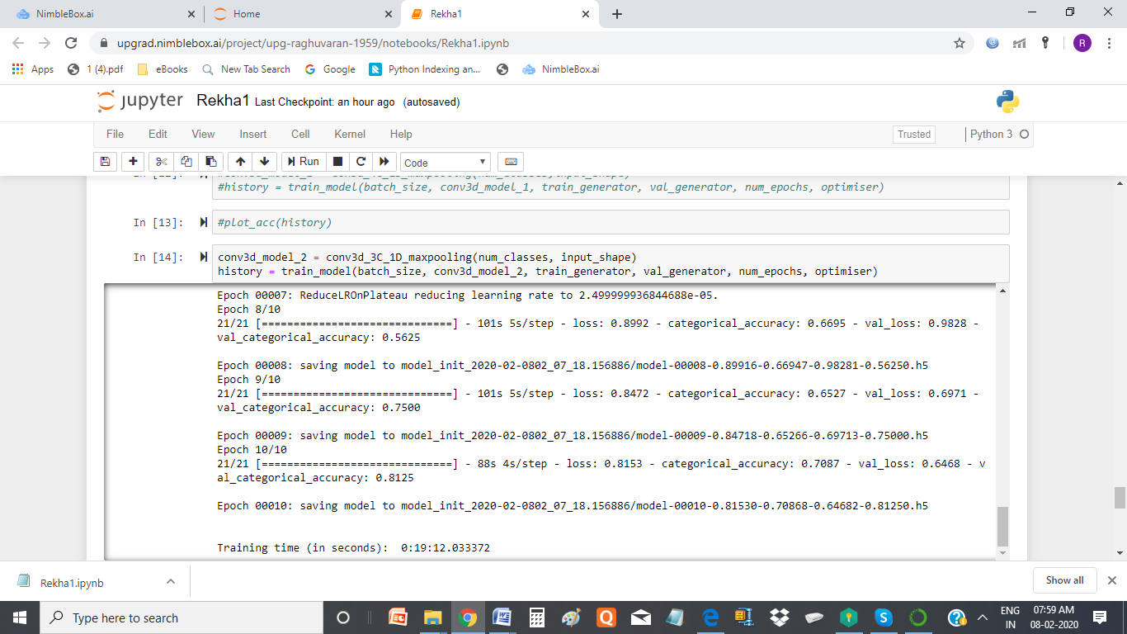

Conclusion: we have validation accuracy around 60%, But the model overfits in most of the epoc

## Batch size 32 , all 30 images per video, learning rate = 0.0001 , image size = 100x100 and epoch = 20

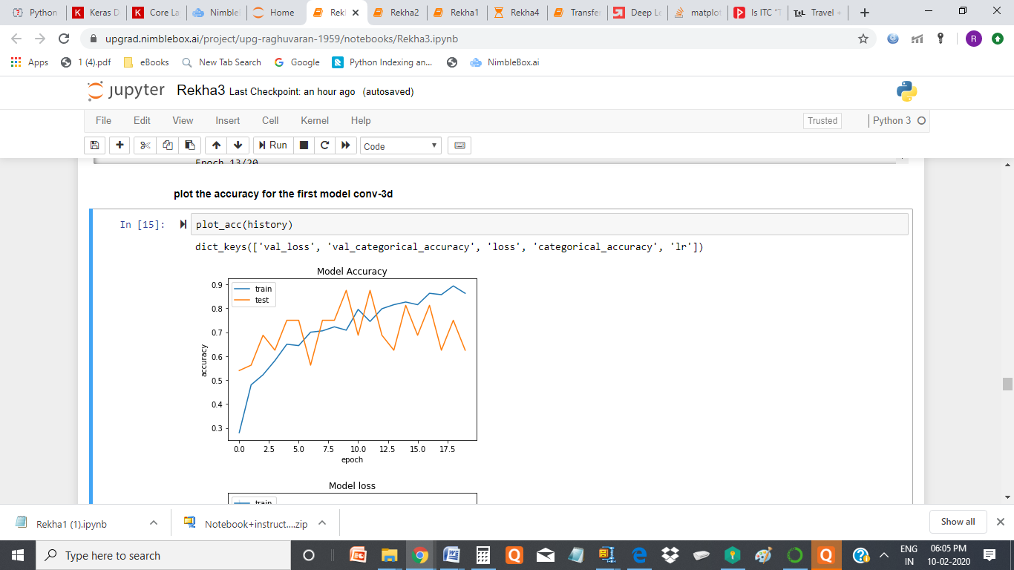

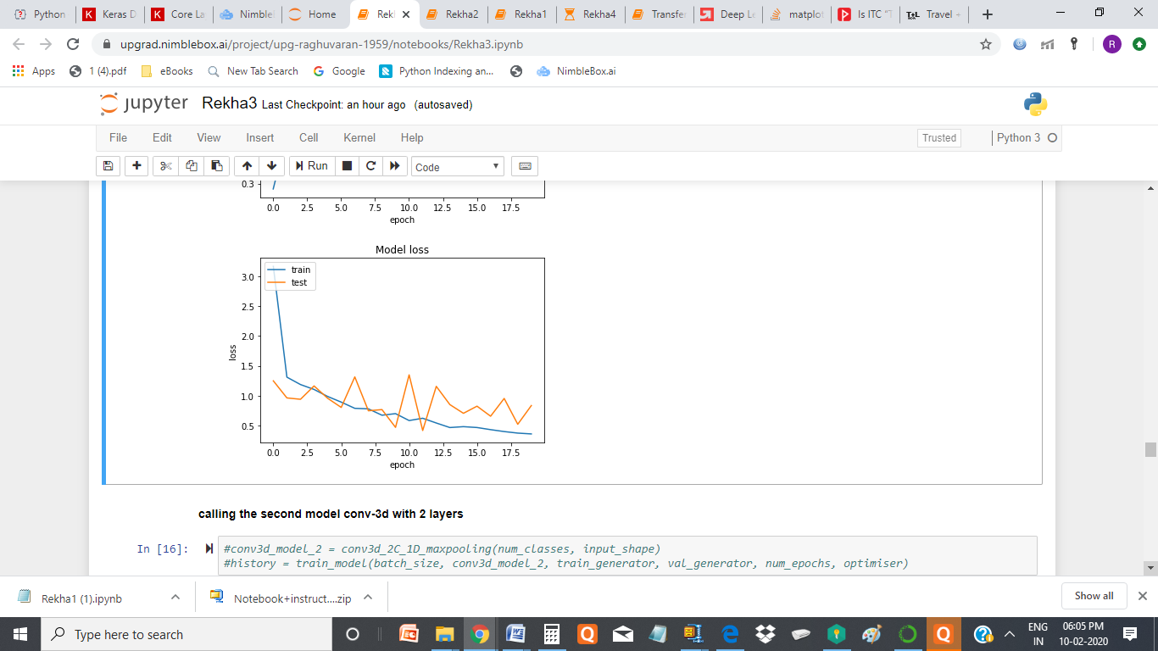

**Conclusion : This model looks ok for me , as the model is not over fitted and the accuracy in two of the epoc is 87.5%**

# 2. MODEL 2 - 2 Layer CON3D ,

## Batch size 32 , 30 images per video, learning rate = 0.0001 , image size = 100x100 and epoch = 20, with 64 filters in both the conv layer

Result : Resource Exhausted Error ,

ResourceExhaustedError: OOM when allocating tensor with shape[32,64,30,100,100]

Trainable Parameters = 3,099,653

Non-trainable params: 256

## Batch size 32 , 15 images per video, learning rate = 0.0001 , image size = 100x100 and epoch = 20, with 64 filters in both the conv layer

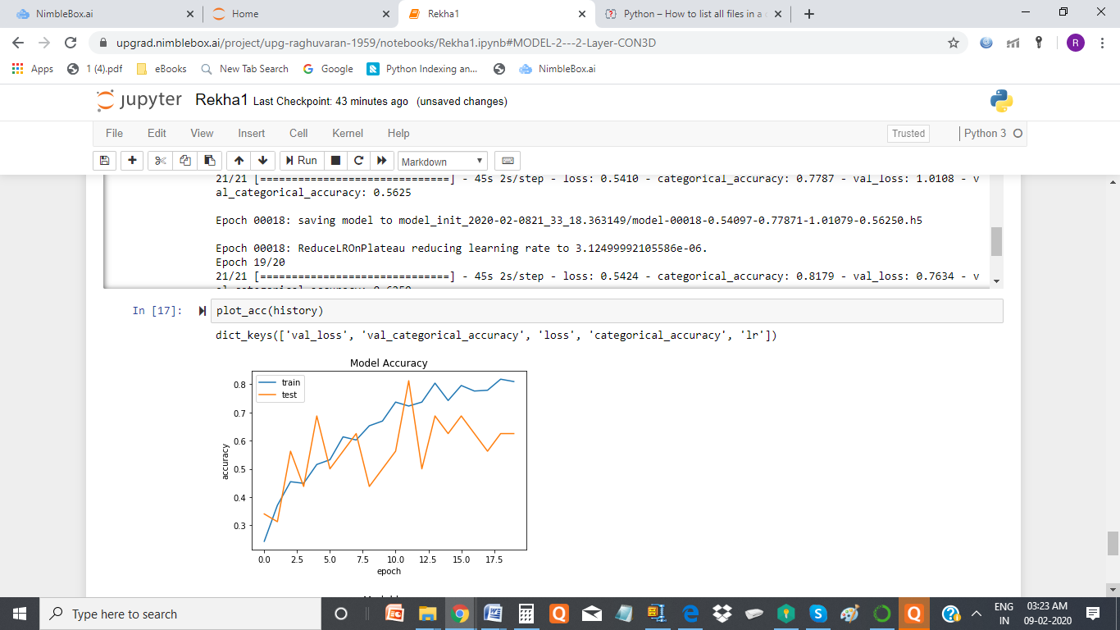

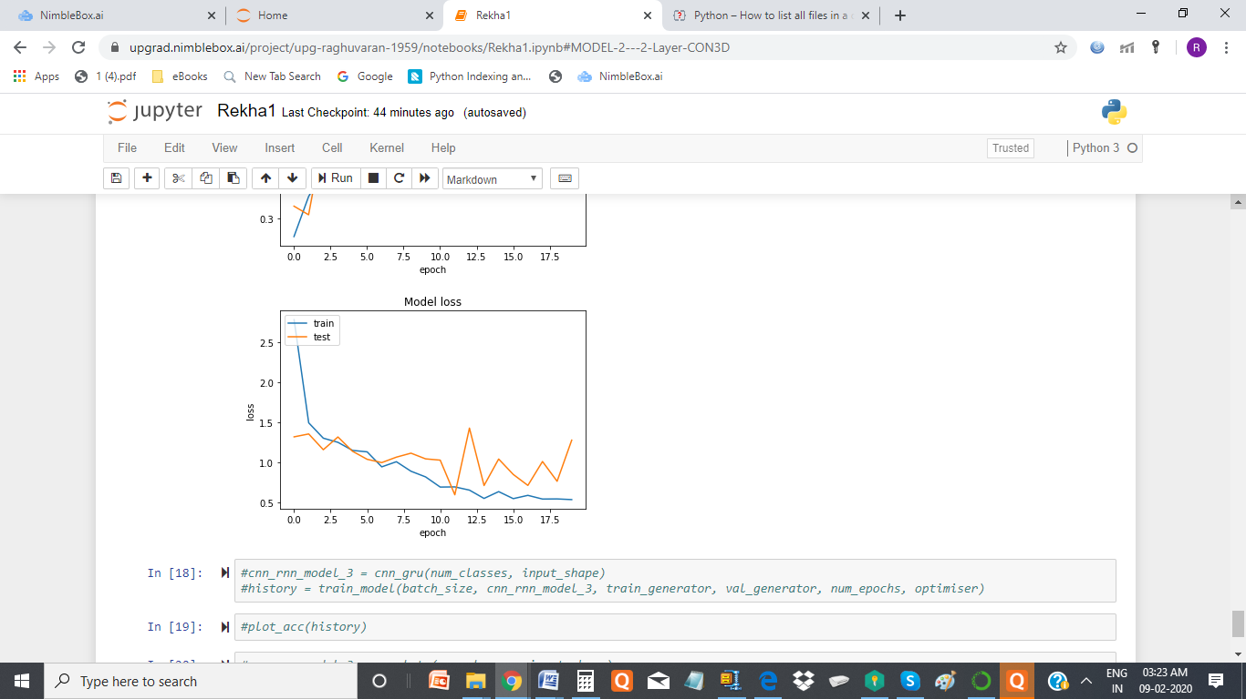

**Conclusion:** the accuracy graph clearly indicates , as validation accuracy is decreasing continuously with epoc , the model is overfitted. Not a good model.

## Batch size 32 , 22 images per video, learning rate = 0.0001 , image size = 100x100 and epoch = 20, with 64 filters in both the conv layer

Result : Resource Exhausted Error ,

ResourceExhaustedError: OOM when allocating tensor with shape[32,64,22,100,100]

Trainable Parameters = 2,099,653

Non-trainable params: 256

## Batch size 32 , 22 images per video, learning rate = 0.0001 , image size = 100x100 and epoch = 20, with 32 filters in both conv layer

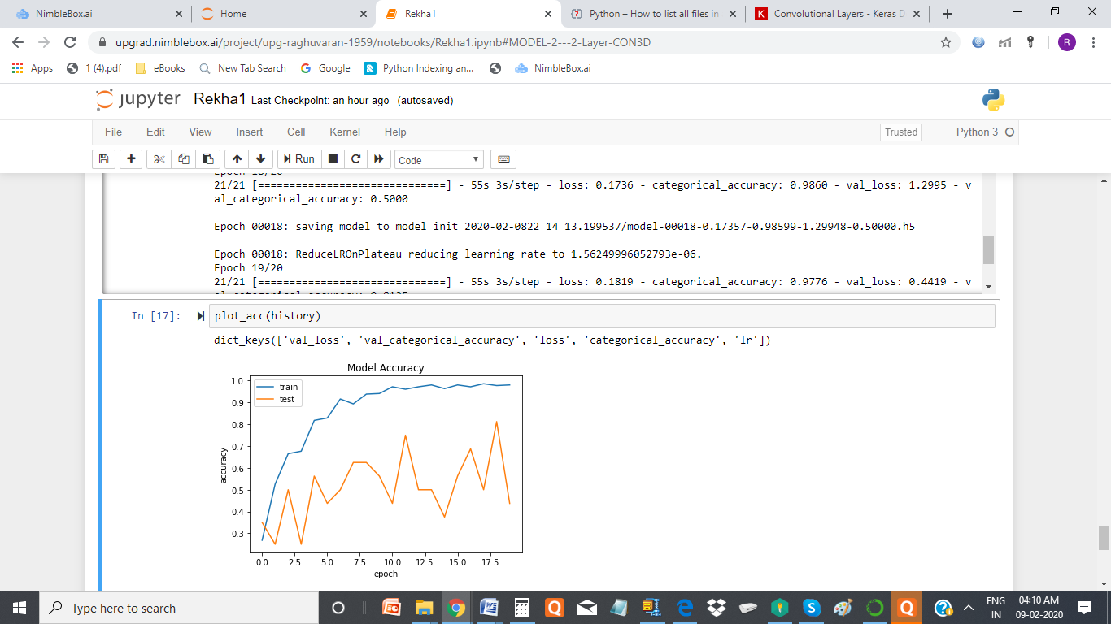

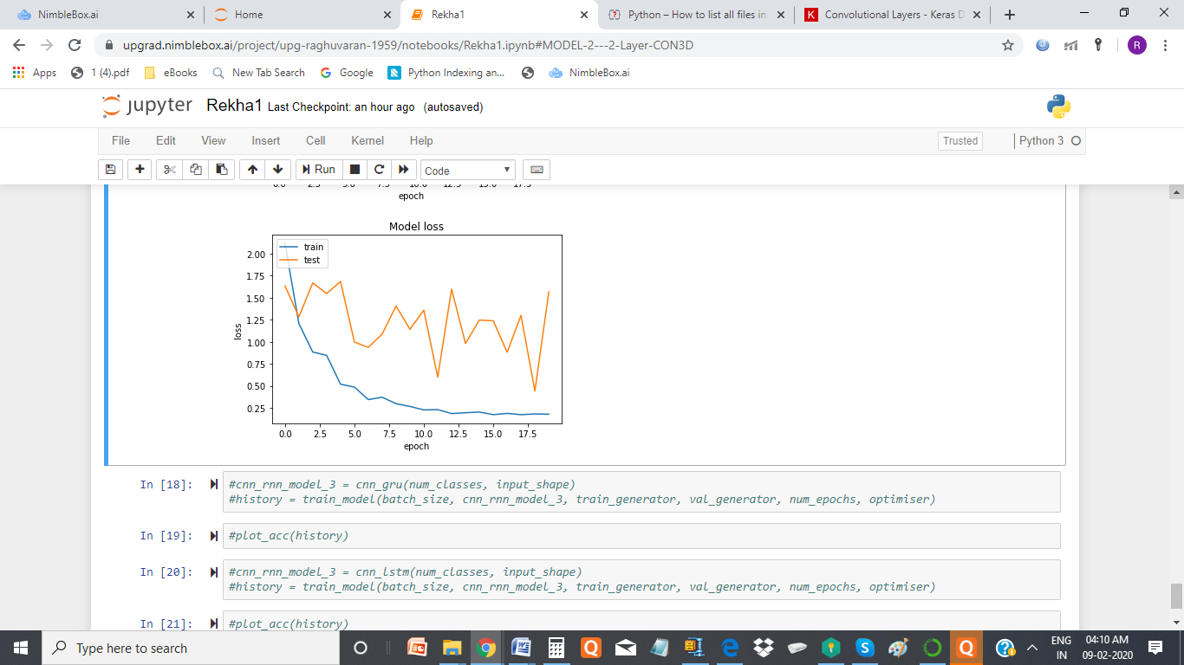

**Conclusion:** the accuracy graph clearly shows that in each epoc , the validation accuracy reduces , model overfitted , so it is not a good model

## Batch size 32 ,30 images per video, with initial learning rate = 0.0001 , image size = 100x100 and epoch = 20, with 32 filters in both conv layer

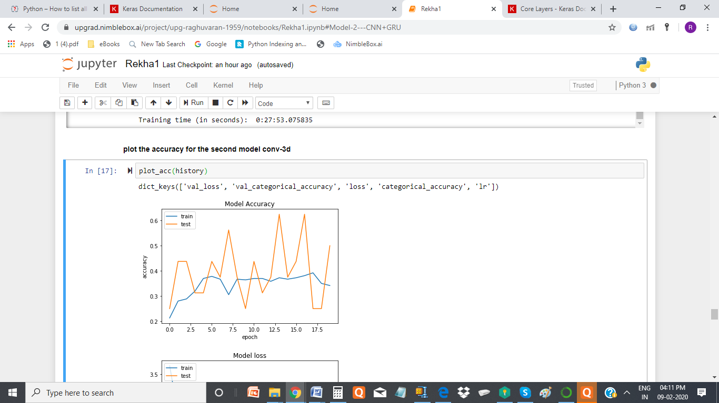

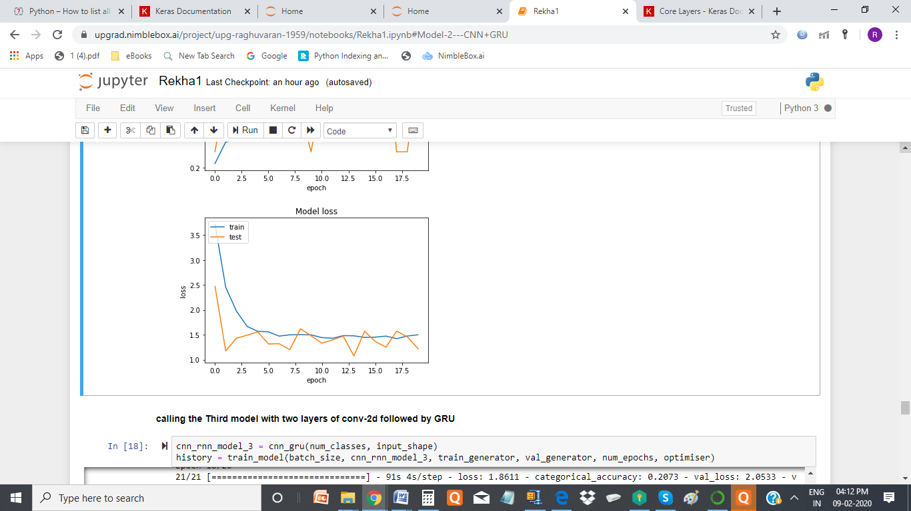

**Conclusion:** The Accuracy graph shows that the model is good , The model is not over fitted, the max accuracy in one of the epoc is above 70%. I fell this is the good model.

# 3. Model 3 - CNN+GRU

# Batch size = 32 , learning rate = 0.001, epoch=20, included all the 30 images , image size = 100x100 , with relu activation in dense layer

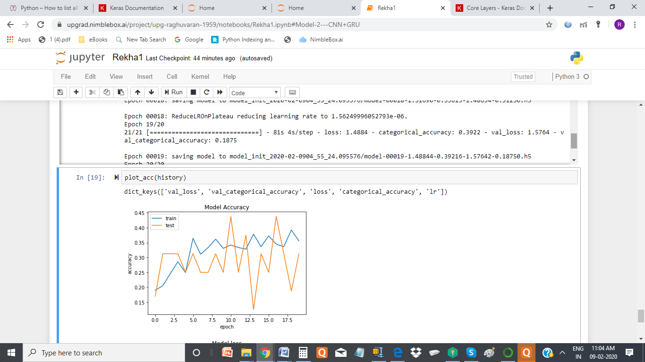

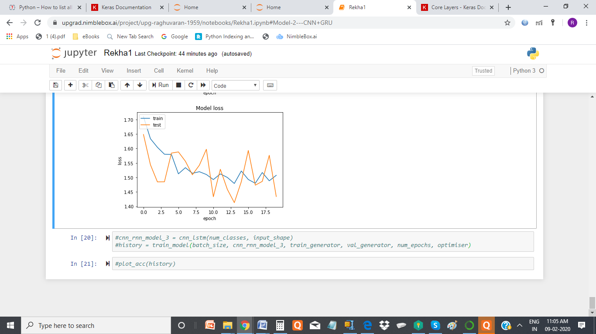

**Conclusion** : This model is not so good , as accuracy does not reach above 50% and we see that model is over fitted in most of the epoc.

# Batch size = 32 , learning rate = 0.001, epoch=20, included all the 30 images , image size = 120x120 without relu activation in dense layer

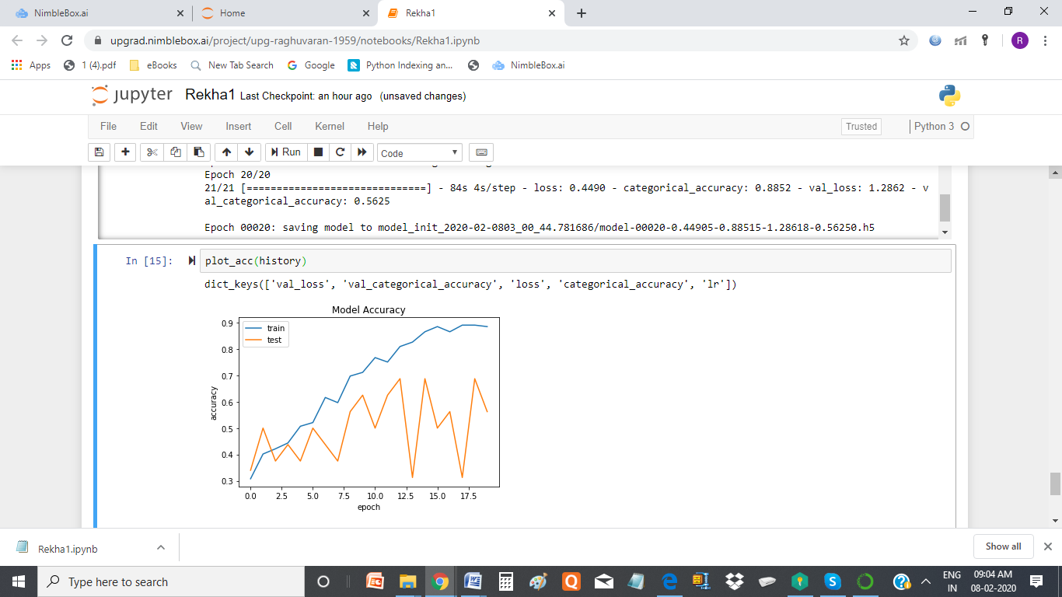

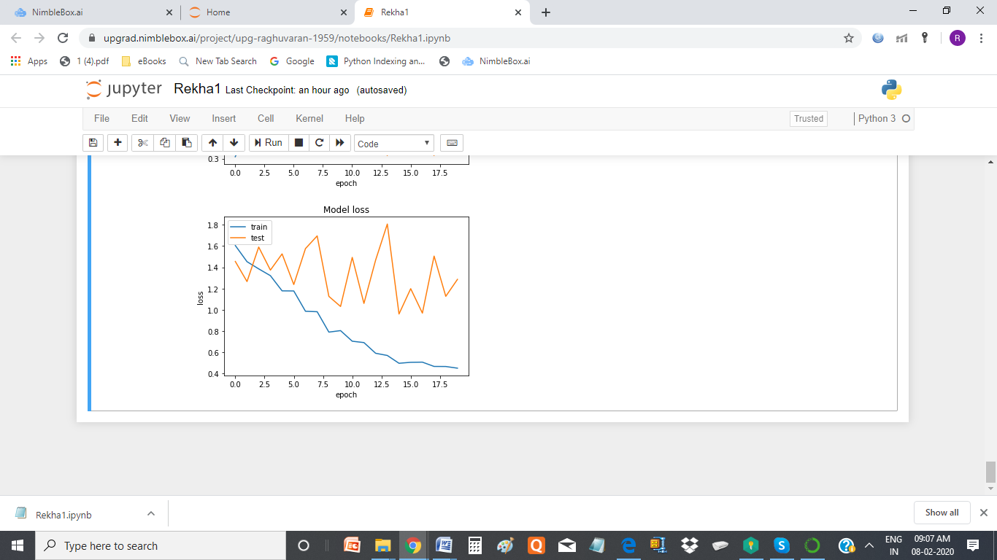

**Conclusion**: accuracy graph show that , the model is overfitted

## Batch size 32, with initial learning rate = 0.0001, 15 images per video, image size = 120x120 , without relu activation in dense layer

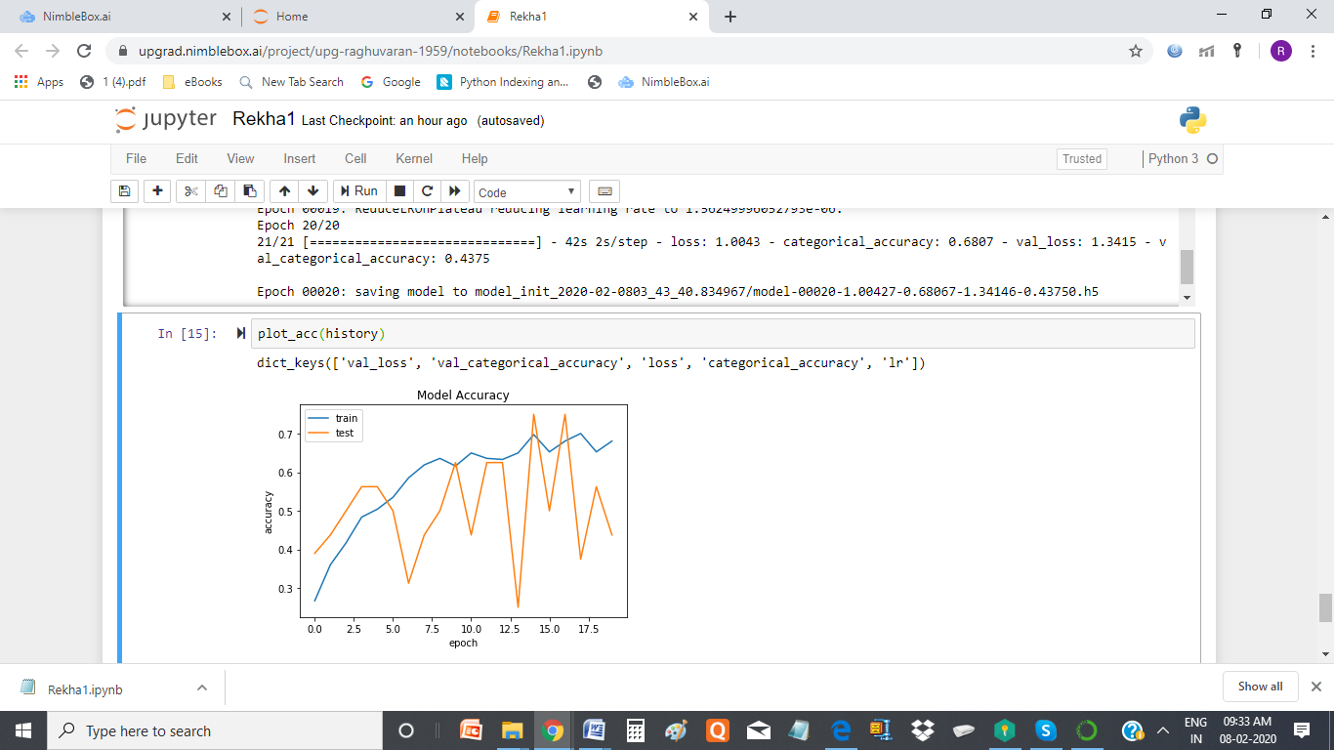

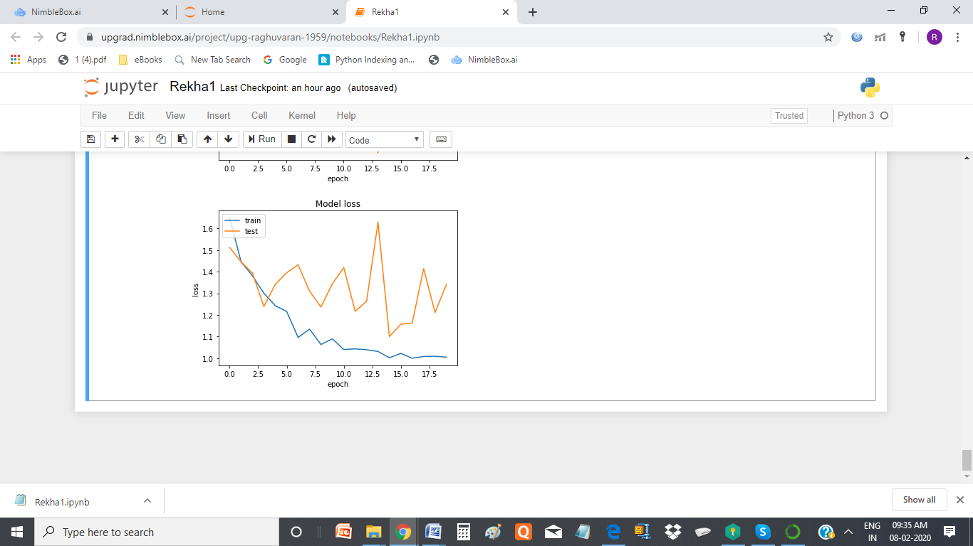

**Conclusion** : Model over fits.

## Batch size 32, initial learning rate = 0.0001, 15 images per video, image size is 160x120 without relu activation in dense layer

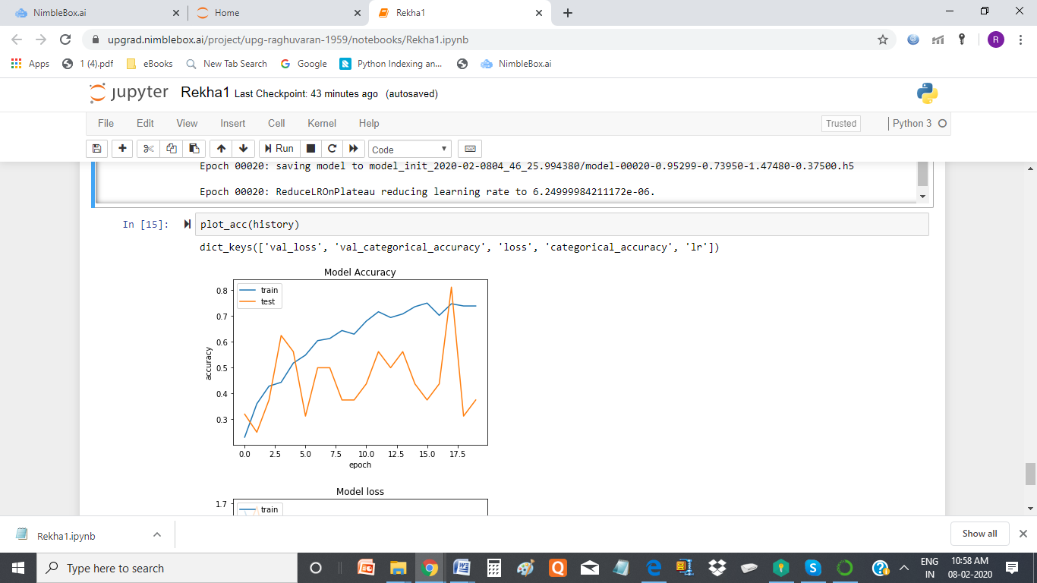

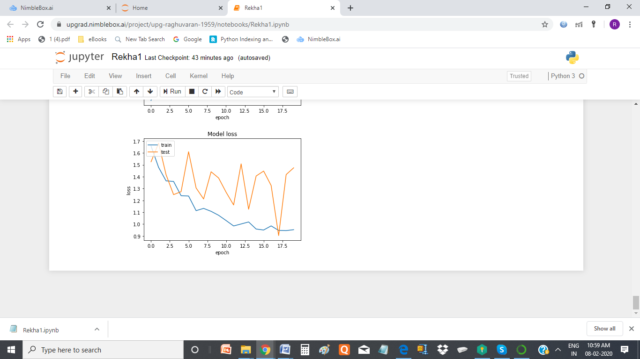

**Conclusion**: Model over fits

## Batch size 32, learning rate = 0.0001, 30 images per video, image size is 100x100, Number of units in GRU =128 , without relu activation in dense layer

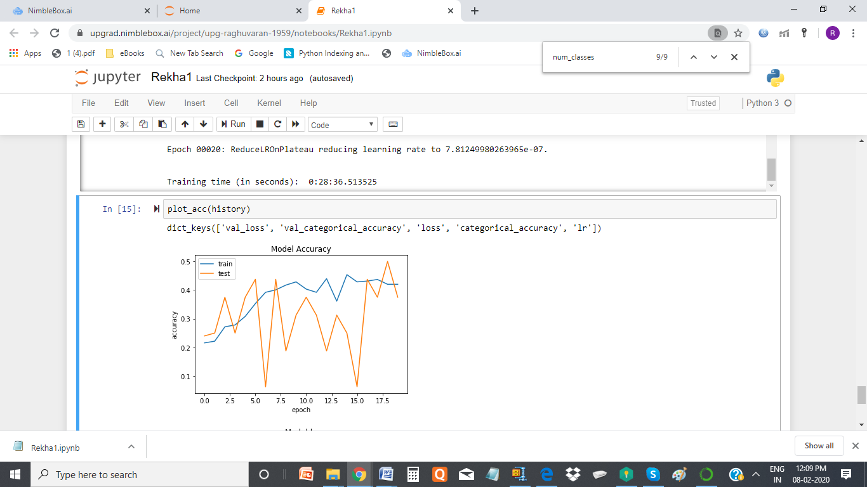

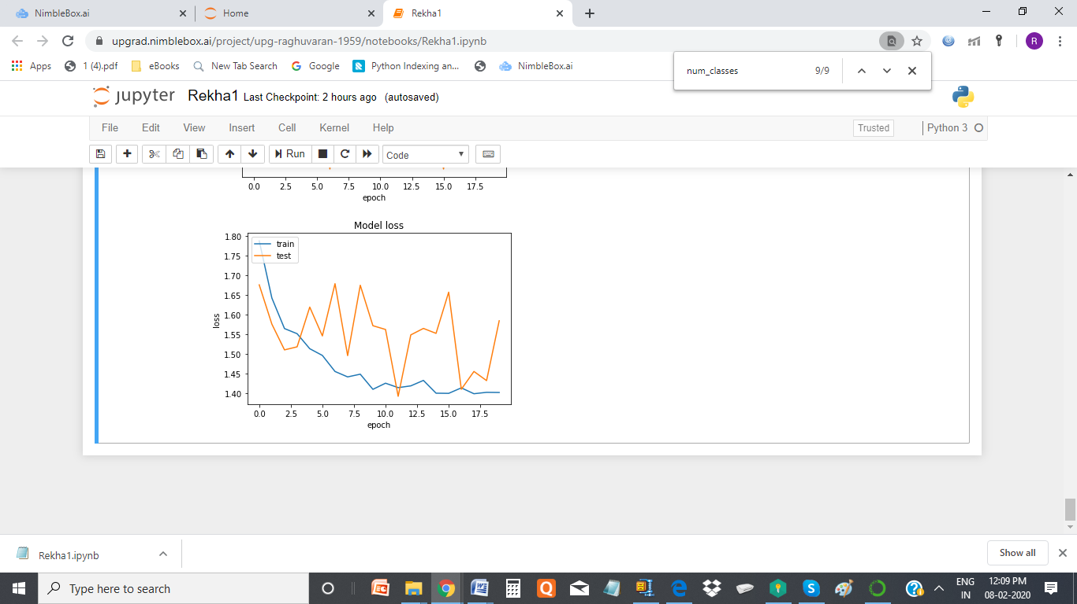

**Conclusion** : model overfits , Accuracy is very low around 37% to 45%

## Batch size 32, learning rate = 0.0001, 30 images per video, image size is 100x100, Number of units in GRU =128, by adding dropout 0.5 and without relu activation in dense layer

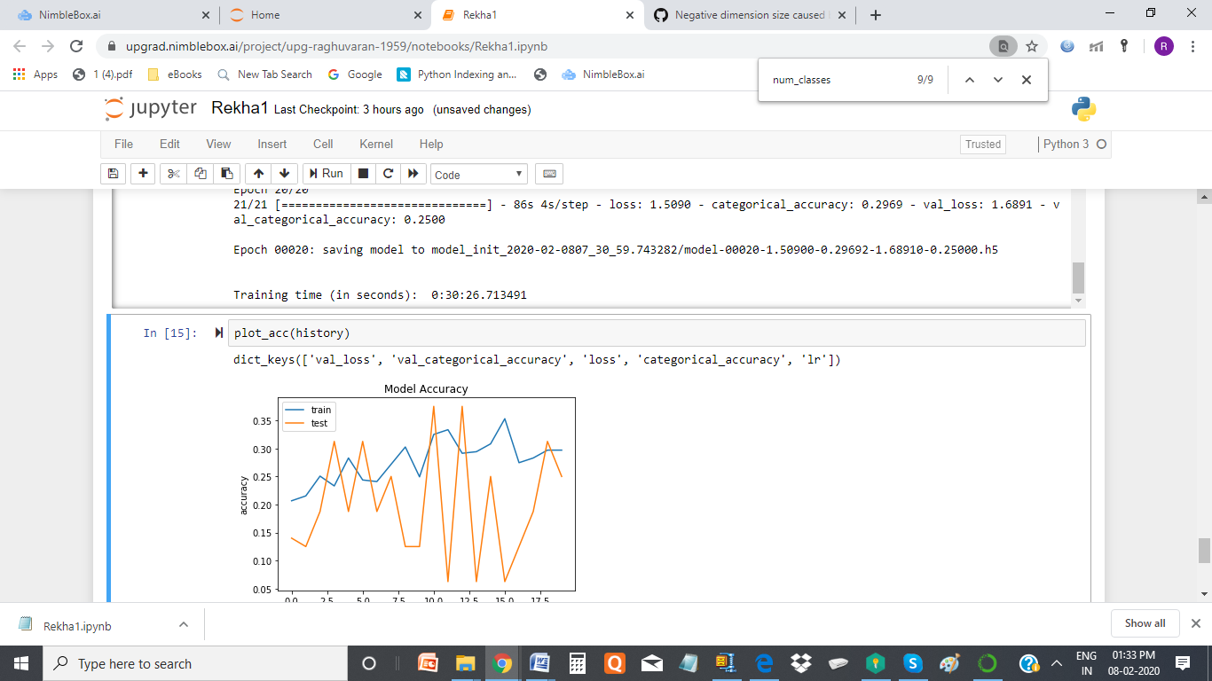

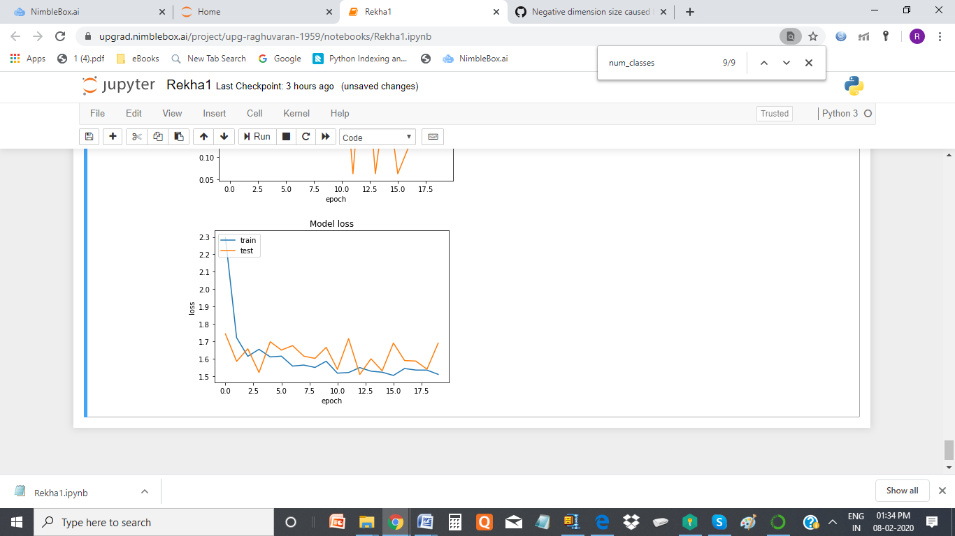

Conclusion : Model Over fit

## Batch size 32, learning rate = 0.0001, 30 images per video, image size is 100x100, Number of units in GRU =128, with batch normalisation in the conv 2D without relu activation in dense layer

## 

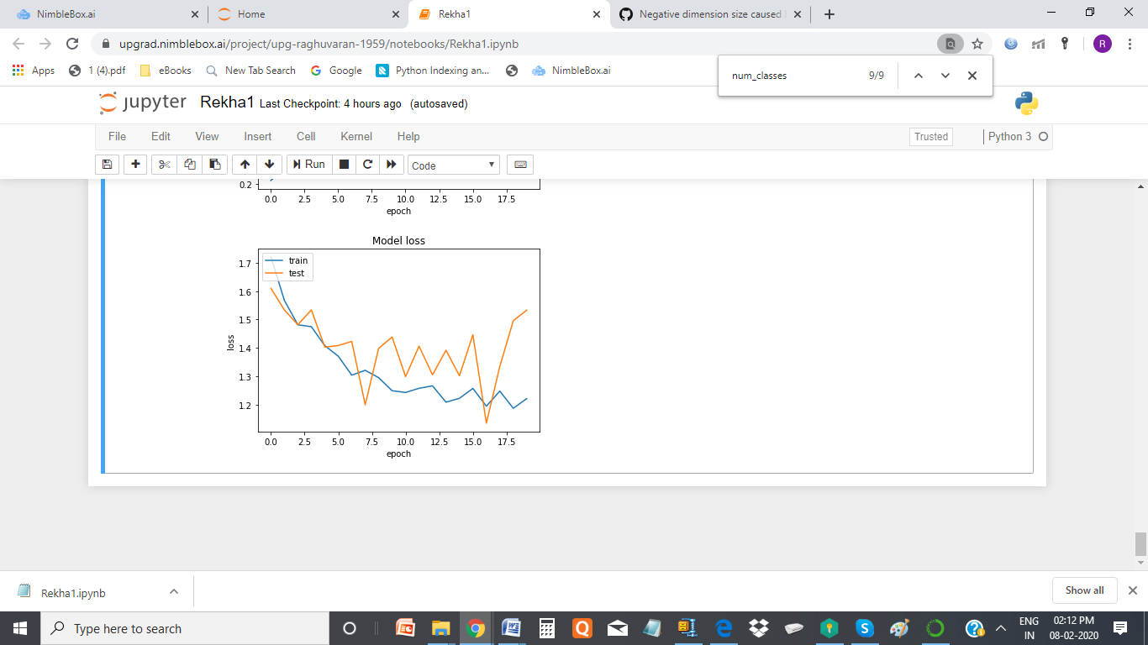

**Conclusion : This model looks better for me , as the model is not over fitted and the accuracy in 3 epoc is 70% to 75%**

## Batch size 32, learning rate = 0.0001, 30 images per video, image size is 100x100, Number of units in GRU =128, with batch normalisation and dropout(.5) in the conv 2D, without relu activation in dense layer

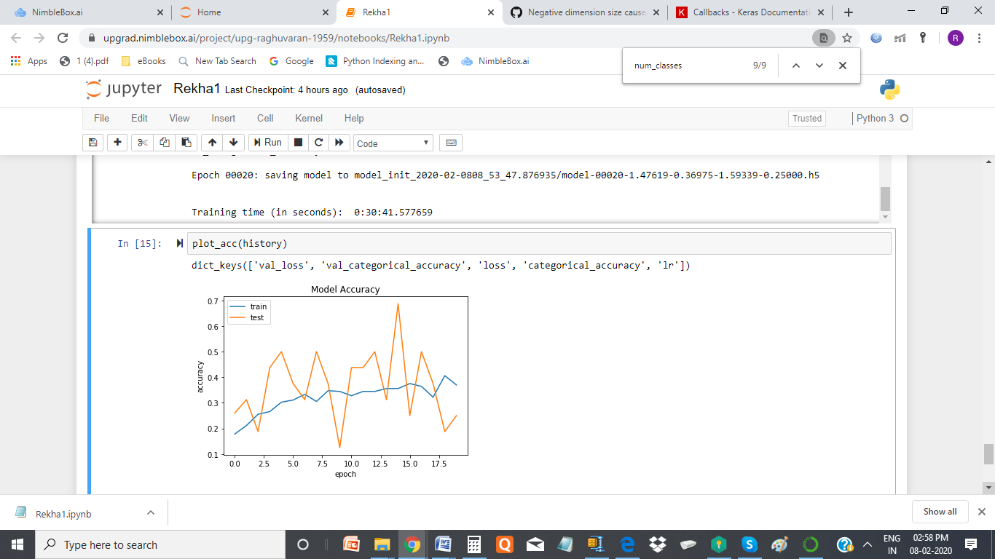

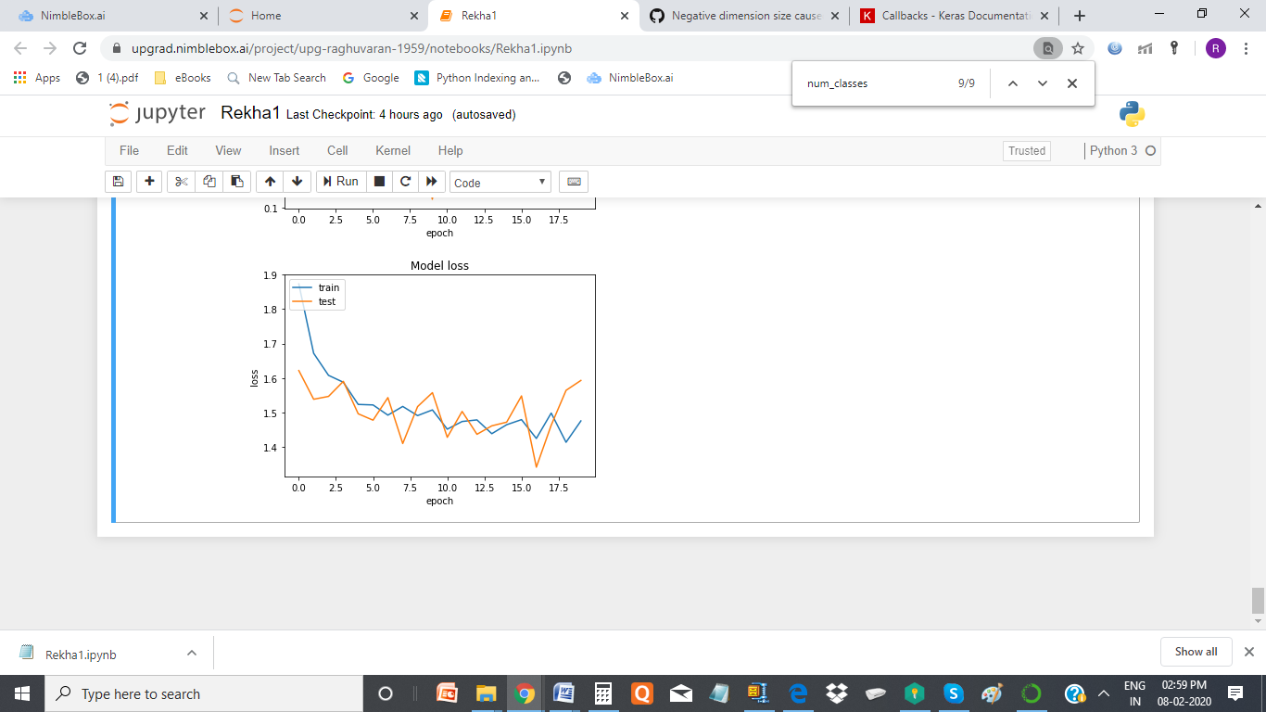

**Conclusion : This model looks ok to me , as the model is not over fitted and the accuracy drops below 70% after adding dropout in dense layer**

# 4. Model 4 - CNN+LSTM

## Batch size 32, learning rate = 0.0001, 30 images per video, image size is 100x100, with batch normalisation and dropout(.5) in the conv 2D, and passing through LSTM, without relu activation in dense layer

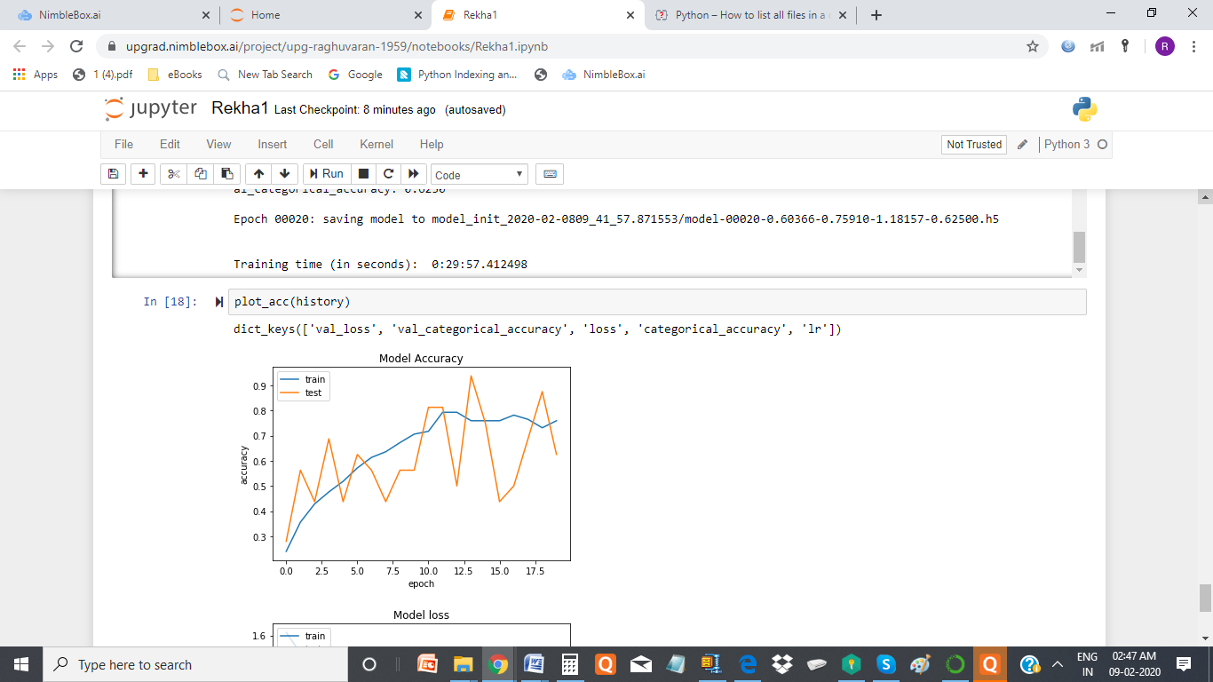

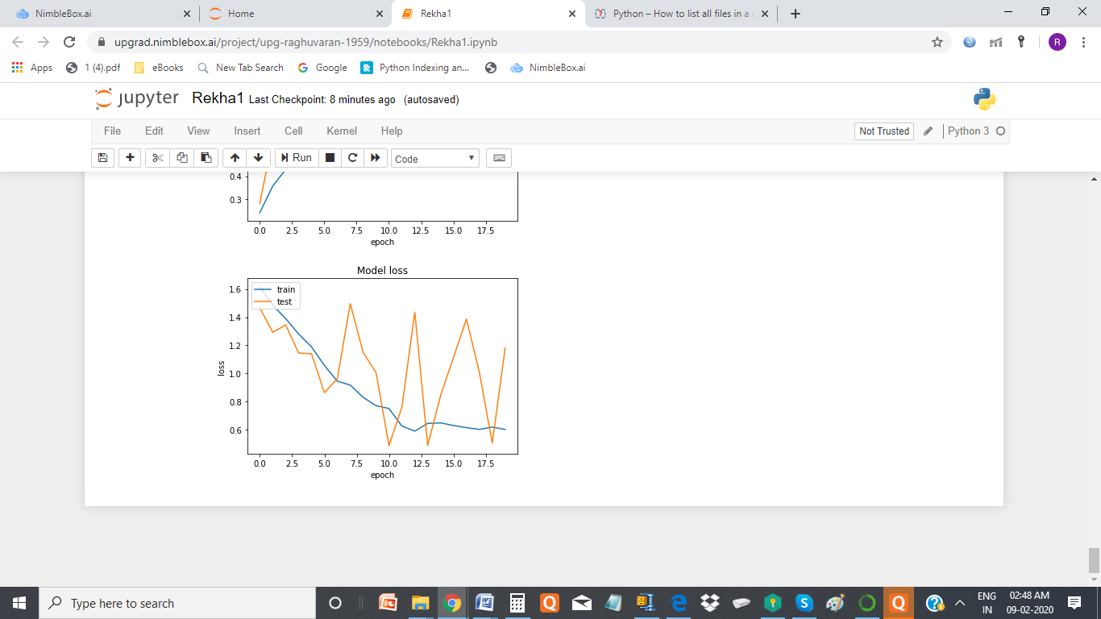

**Conclusion : This model looks ok for me , as the model is not much over fitted and the accuracy in one of the epoc is 91%**